ASEAN PATENT EXAMINATION COOPERATION (ASPEC) FORM 1
REQUEST FORM

1. Name of Applicant(s) (Further applicants are to be indicated on an additional sheet)
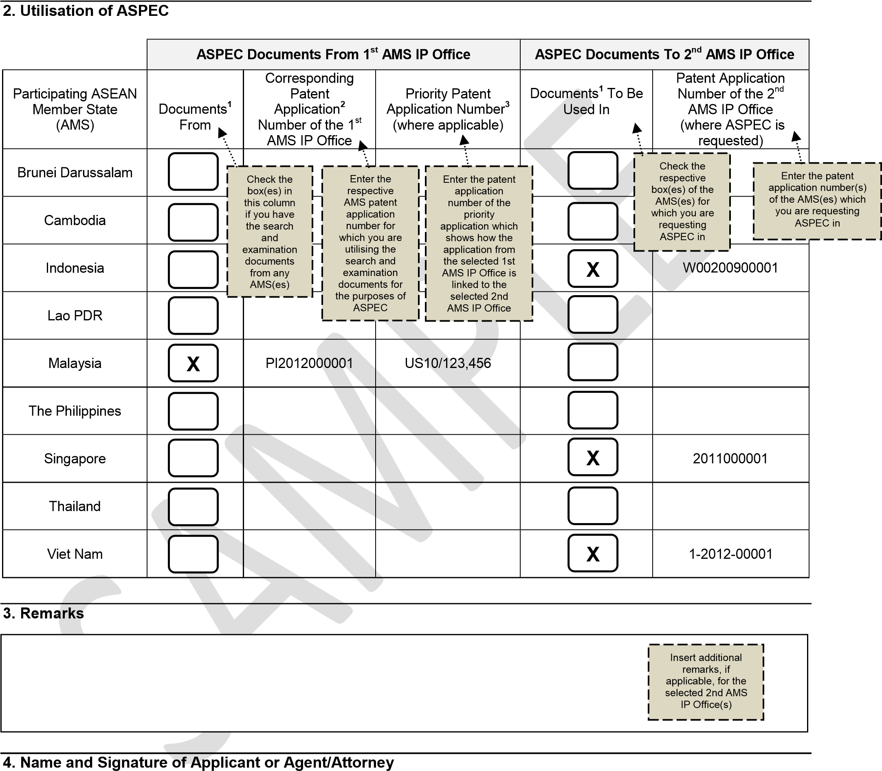

_______________________________________ ______________
Name and Signature Date

- Documents submitted should include a copy of (i) a search report, (ii) an examination report, and (iii) claims referred to in the examination report. A claim correspondence table is optional.
- A patent application from another ASPEC participating ASEAN country is a corresponding patent application if it is linked by a Paris Convention priority claim to the patent application of which ASPEC is requested for, and vice versa, or it shares the same priority claim with the patent application of which ASPEC is requested for, from another patent application of a Paris Convention member country.
- Please indicate the patent application number which the corresponding application claims priority from, where applicable.
Version: 12 Feb 2014

