Procedures to file a request to the JPO (Japan Patent Office) for Patent Prosecution Highway Pilot Program between the JPO and the DIP (Department of Intellectual Property)

Applicants can request accelerated examination by a prescribed procedure including submission of relevant documents on an application which is filed with the JPO and satisfies the following requirements under the JPO-DIP Patent Prosecution Highway pilot program based on the DIP application.
When filing a request for the PPH pilot program, an applicant must submit a request form “The Explanation of Circumstances Concerning Accelerated Examination” based on the procedure prescribed in “the Guidelines of the Accelerated Examination and Appeal." Under the PPH pilot program, an applicant is not required to fill in the section “2. the disclosure of prior arts and comparison between the claimed invention and prior art” in “The Explanation of Circumstances Concerning Accelerated Examination”.
The offices may terminate the PPH pilot program if the volume of participation exceeds manageable level, or for any other reason. Ex ante notice will be published if the PPH pilot program is terminated.
The PPH pilot program will be in effect for two (2) years commencing on January 1, 2018 and will end on December 31, 2019. However, the program may be extended after a joint DIP-JPO review and assessment of the program implementation.

1. Requirements
(a) The JPO application (including a PCT national phase application) is
(i) an application which validly claims priority under the Paris Convention to the DIP application(s) (examples are provided in ANNEX, figure A, B, C, F, G and H), or
(ii) a PCT national phase application without priority claim (examples are provided in ANNEX, figure I), or
(iii) an application which validly claims priority under the Paris Convention to the PCT application(s) without priority claim (examples are provided in ANNEX, figure J, K and L).
The JPO application, which validly claims priority to multiple DIP or direct PCT applications, or which is the divisional application validly based on the originally filed application that is included in (i) to (iii) above, is also eligible.
The pilot program is not applicable on the basis of DIP ‘petty patent’ applications.

(b) At least one corresponding application exists in the DIP and has one or more claims that are determined to be patentable/allowable by the DIP.
The corresponding application can be the application which forms the basis of the priority claim, an application which derived from the DIP application which forms the basis of the priority claim (e.g. a divisional application of the DIP application), or an DIP national phase application of a PCT application.
Claims are “determined to be allowable/patentable” when the DIP examiner clearly identifies the claims to be allowable/patentable in the latest office action, even if the application is not granted for patent yet. The office action includes one of the following:
(i) Examination Report
(ii) Search Report
(iii) Rejection Report
(iv) Appeal Decision

(c) All claims on file, as originally filed or as amended, for examination under the PPH must sufficiently correspond to one or more of those claims indicated as allowable in the DIP.
Claims are considered to "sufficiently correspond" where, accounting for differences due to translations and claim format, the claims in the JPO are of the same or similar scope as the claims in the DIP, or the claims in the JPO are narrower in scope than the claims in the DIP.
In this regard, a claim that is narrower in scope occurs when an DIP claim is amended to be further limited by an additional feature that is supported in the specification (description and/or claims).
A claim in the JPO which introduces a new/different category of claims to those claims indicated as allowable in the DIP is not considered to sufficiently correspond. For example, where the DIP claims only contain claims to a process of manufacturing a product, then the claims in the JPO are not considered to sufficiently correspond if the JPO claims introduce product claims that are dependent on the corresponding process claims.
Any claims amended or added after the grant of the request for participation in the PPH pilot program need not to sufficiently correspond to the claims indicated as allowable in the DIP application.

(d) The JPO has not begun examination of the application at the time of request for the PPH (an example is provided in ANNEX, figure M).

(e) A “Request for Substantive Examination” must have been filed at the JPO either at the time of the PPH request or previously.

2. Documents to be submitted
Documents (a) to (d) below must be submitted by attaching to “The Explanation of Circumstances Concerning Accelerated Examination”.
Note that even when it is not needed to submit documents below, the name of the documents must be listed in “The Explanation of Circumstances Concerning Accelerated Examination” (Please refer to the Example form for the detail).

(a) Copies of all office actions (which are relevant to substantial examination for patentability in the DIP), which were sent for the corresponding application by the DIP, and translations of them.
Either Japanese or English is acceptable as translation language.

(b) Copies of all claims determined to be patentable/allowable by the DIP, and translations of themError: Reference source not found.
Either Japanese or English is acceptable as translation language.

(c) Copies of references cited by the DIP examiner
If the references are patent documents, the applicant doesn’t have to submit them because the JPO usually possesses them. When the JPO does not possess the patent document, the applicant has to submit the patent document at the examiner’s request. Non-patent literature must always be submitted.
The translations of the references are unnecessary.

(d) Claim correspondence table
The applicant requesting PPH must submit a claim correspondence table, which indicates how all claims in the JPO application sufficiently correspond to the patentable/allowable claims in the DIP application.
When claims are just literal translation, the applicant can just write down that “they are the same” in the table. When claims are not just literal translation, it is necessary to explain the sufficient correspondence of each claim based on the criteria 1. (c) (Please refer to the Example form).

When the applicant has already submitted above documents (a) to (d) to the JPO through simultaneous or past procedures, the applicant may incorporate the documents by reference and does not have to attach them.

3. Example of “The Explanation of Circumstances Concerning Accelerated Examination” for filing request an accelerated examination under the PPH pilot program

(1) Circumstances

When an applicant files a request for an accelerated examination under the PPH pilot program to the JPO, an applicant must submit a request form “The Explanation of Circumstances Concerning Accelerated Examination” based on the procedure prescribed in “the Guidelines of the Accelerated Examination and Appeal".

The applicant must indicate that the application is included in (i) to (iii) of 1. (a), and that the accelerated examination is requested under the PPH pilot program. The application number, publication number, or a patent number of the corresponding DIP application(s) also must be written.

*In the case that the application which has one or more claims that are determined to be patentable/allowable is different from the DIP application(s) included in (i) to (iii) of 1. (a) (for example, the divisional application of the basic application), the application number, publication number, or a patent number of the application(s) which has claims determined to be patentable/allowable and the relationship between those applications also must be written.

(2) Documents to be submitted
The applicant must list all required documents mentioned above 2. in an identifiable way, even when applicant omits to submit certain documents.

(3) Notice
Forms of “The Explanation of Circumstances Concerning Accelerated Examination” are different between on-line procedure and paper procedure. Please refer to the examples of forms when filling in (“Form 1 for Accelerated Examination” for on-line procedures, and “Form 2 for Accelerated Examination” for paper procedures.).

Example form of on-line procedures
(Example of the request based on the claims indicated patentable/allowable in the written opinion of the report on the state of the art)

【書類名】 早期審査に関する事情説明書
The name of this paper

【提出日】 平成００年００月００日
Bibliographical items
Date of filing

【あて先】 特許庁長官殿
Destination

【事件の表示】
【出願番号】 特願 ００００－００００００
Application number

【提出者】
【識別番号】 ０００００００００
【住所又は居所】 ○○県○○市○丁目
【氏名又は名称】 ○○○○○
The name and address of who submit this

【代理人】
【識別番号】 ０００００００００
【住所又は居所】 ○○県○○市○丁目
【氏名又は名称】 ○○ ○○
The name and address of the attorney

【早期審査に関する事情説明】
The explanation of circumstances concerning accelerated examination

１．事情
特許審査ハイウェイに基づく早期審査の申請を行う。
本出願はタイ商務省知的財産局への出願（特許出願番号００００００００）をパリ条約に基づく優先権の基礎出願とする出願である。当該タイ出願に対しては、タイ商務省知的財産局により特許査定が発行されている。
- Circumstances
The accelerated examination is requested under the PPH program.
This application is an application validly claiming the priority under the Paris Convention to the corresponding DIP application (the application number is 000000000), and the Decision to Grant a Patent has been issued by the DIP.

以下において、「引用非特許文献１」とは、「村岡洋一著、「コンピュータサイエンス大学講座（第11巻）コンピュータ・アーキテクチャ」、第2版、株式会社近代科学者、1985年11月、p. 123 - 127」である。
In what follows, “non-patent literature1” is “Yoichi Muraoka, Lecture of Computer Science (vol.11) computer architecture, 2nd edition, Scientist com, Nov. 1985, p.123-127.”

If the name of the document is long (over than 50 letters), it is impossible to write it down directly to the column “【物件名】.” Please write down the full name of the document in the column “【早期審査に関する事情説明】” and name it properly. Then write the name in the column “【物件名】.”
【提出物件の目録】
List up the documents to be submitted
The list of submitted documents

【物件名】 PPH申請書 １
【物件名】 **年**月**日付の拒絶理由通知書の写し及びその翻訳文 １
【物件名】 **年**月**日付の特許査定の写し及びその翻訳文 １
【物件名】 特許可能と判断された請求項の写し及びその翻訳文 １
【物件名】 引用非特許文献１ １

(The name of the document) PPH request form 1
(The name of the document) Copy and translation of Notification of Reasons for Refusal in the DIP on (date) 1
(The name of the document) Copy and translation of grant in the DIP on (date) 1
(The name of the document) Copy and translation of the claims indicated patentable in the report on the state of the art and written opinion in the DIP on (date) 1
(The name of the document) Cited non patent literature1 1

Use the same name as “【物件名】” under “【提出物件の目録】.”

Attach the document here as image file or text.

【添付物件】
The list of attached documents

【物件名】 PPH申請書
PPH request form

【内容】

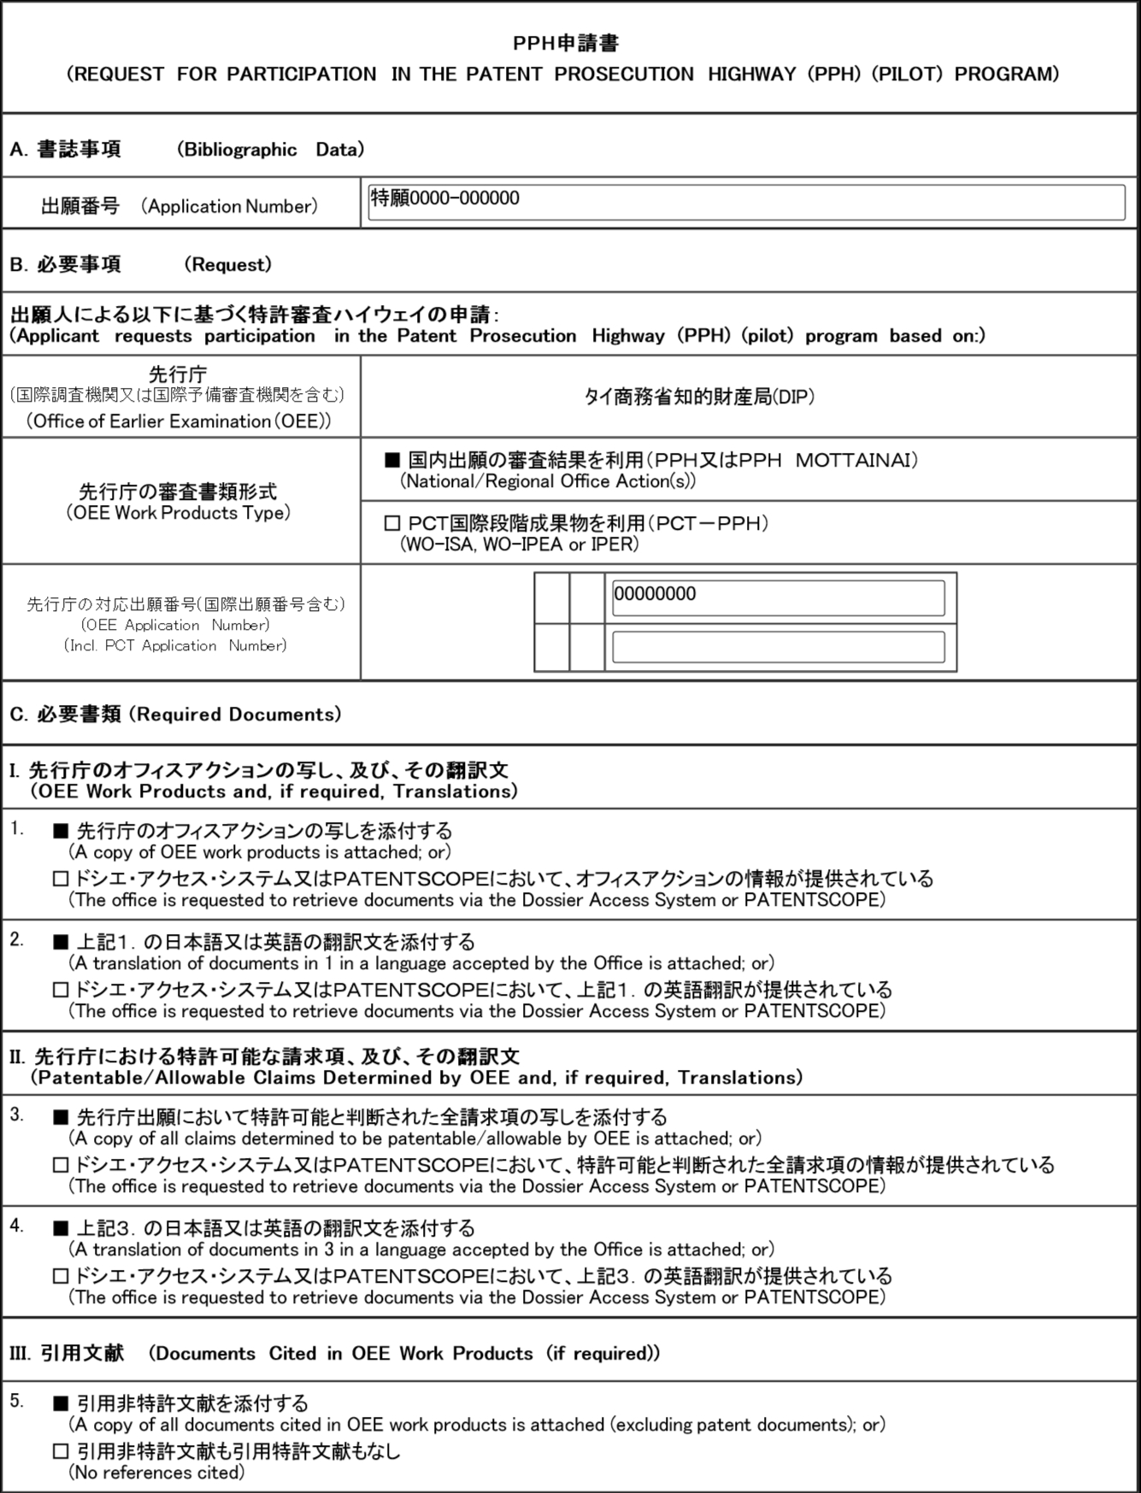

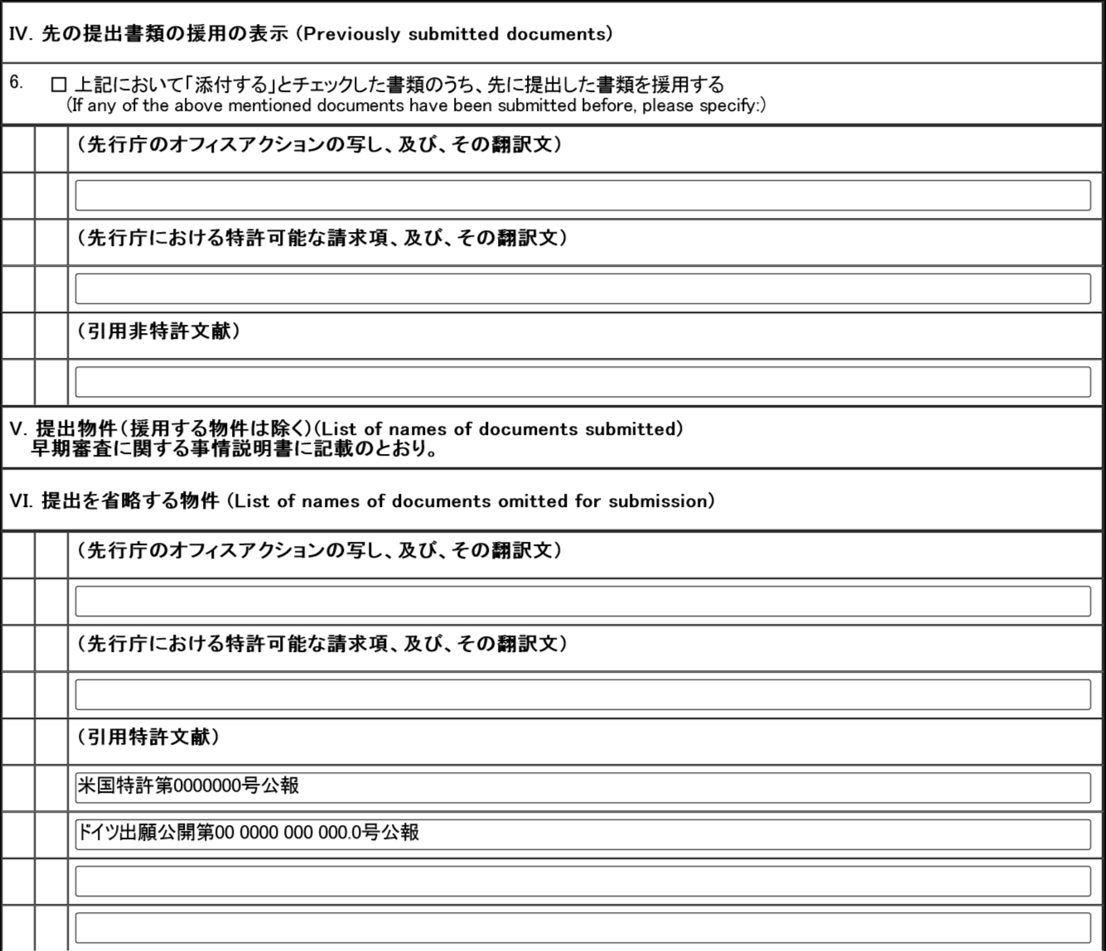
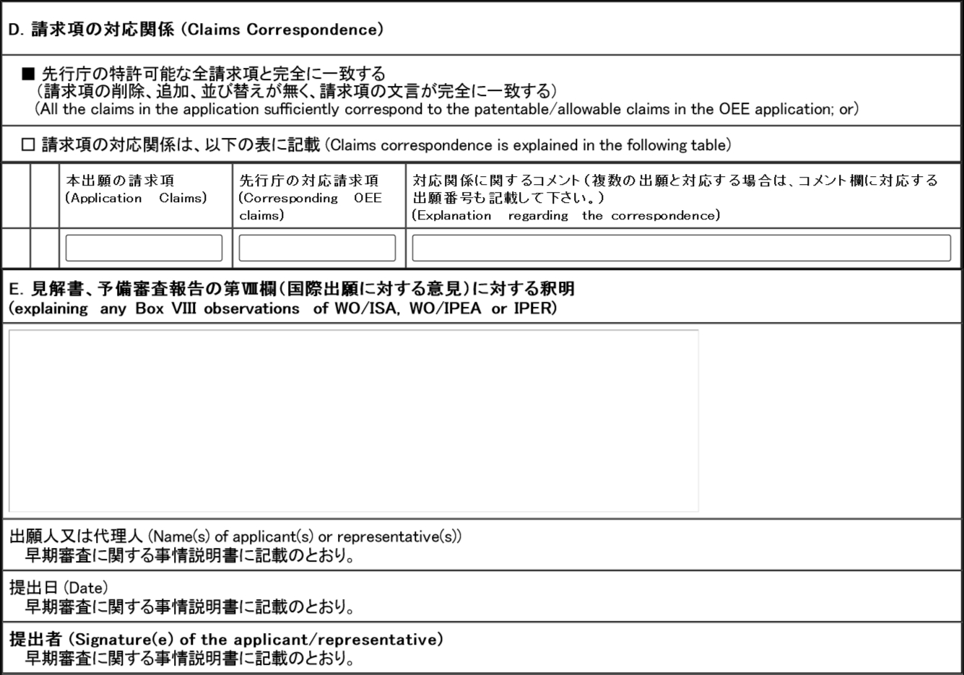

【物件名】 **年**月**日付の拒絶理由通知書及びその翻訳文
Copy and translation of Notification of Reasons for Refusal in the DIP on (date)
Use the same name as “【物件名】” under “【提出物件の目録】.”

【内容】
Attach the copy of the document.

【物件名】 **年**月**日付の特許査定およびその翻訳文
Copy and translation of grant in the DIP on (date)

【内容】
Attach the copy of the document.

【物件名】 特許可能と判断された請求項の写し及びその翻訳文
Copy and translation of the claims indicated patentable in the report on the state of the art and written opinion in the DIP on (date)

【内容】
Attach the copy of the document.

【物件名】 引用非特許文献１
Cited non－patent literature1

【内容】
Attach the copy of the document.

Note that in the case of paper procedure, the pendency period (the period between the request for PPH and the first office action) tends to be longer than on-line procedure.

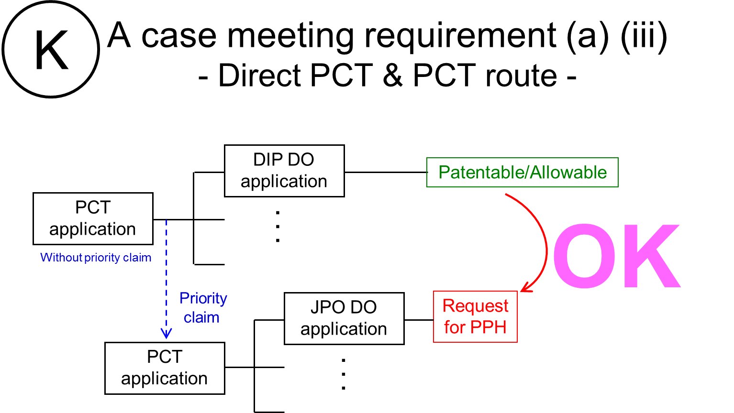

http://www.jpo.go.jp/torikumi/t_torikumi/souki/pdf/v3souki/guideline.pdf
Machine translations will be admissible, but if it is impossible for the examiner to understand the outline of the translated office action or claims due to insufficient translation, the examiner can request the applicant to resubmit translations.
http://www.jpo.go.jp/torikumi/t_torikumi/souki/pdf/v3souki/guideline.pdf

